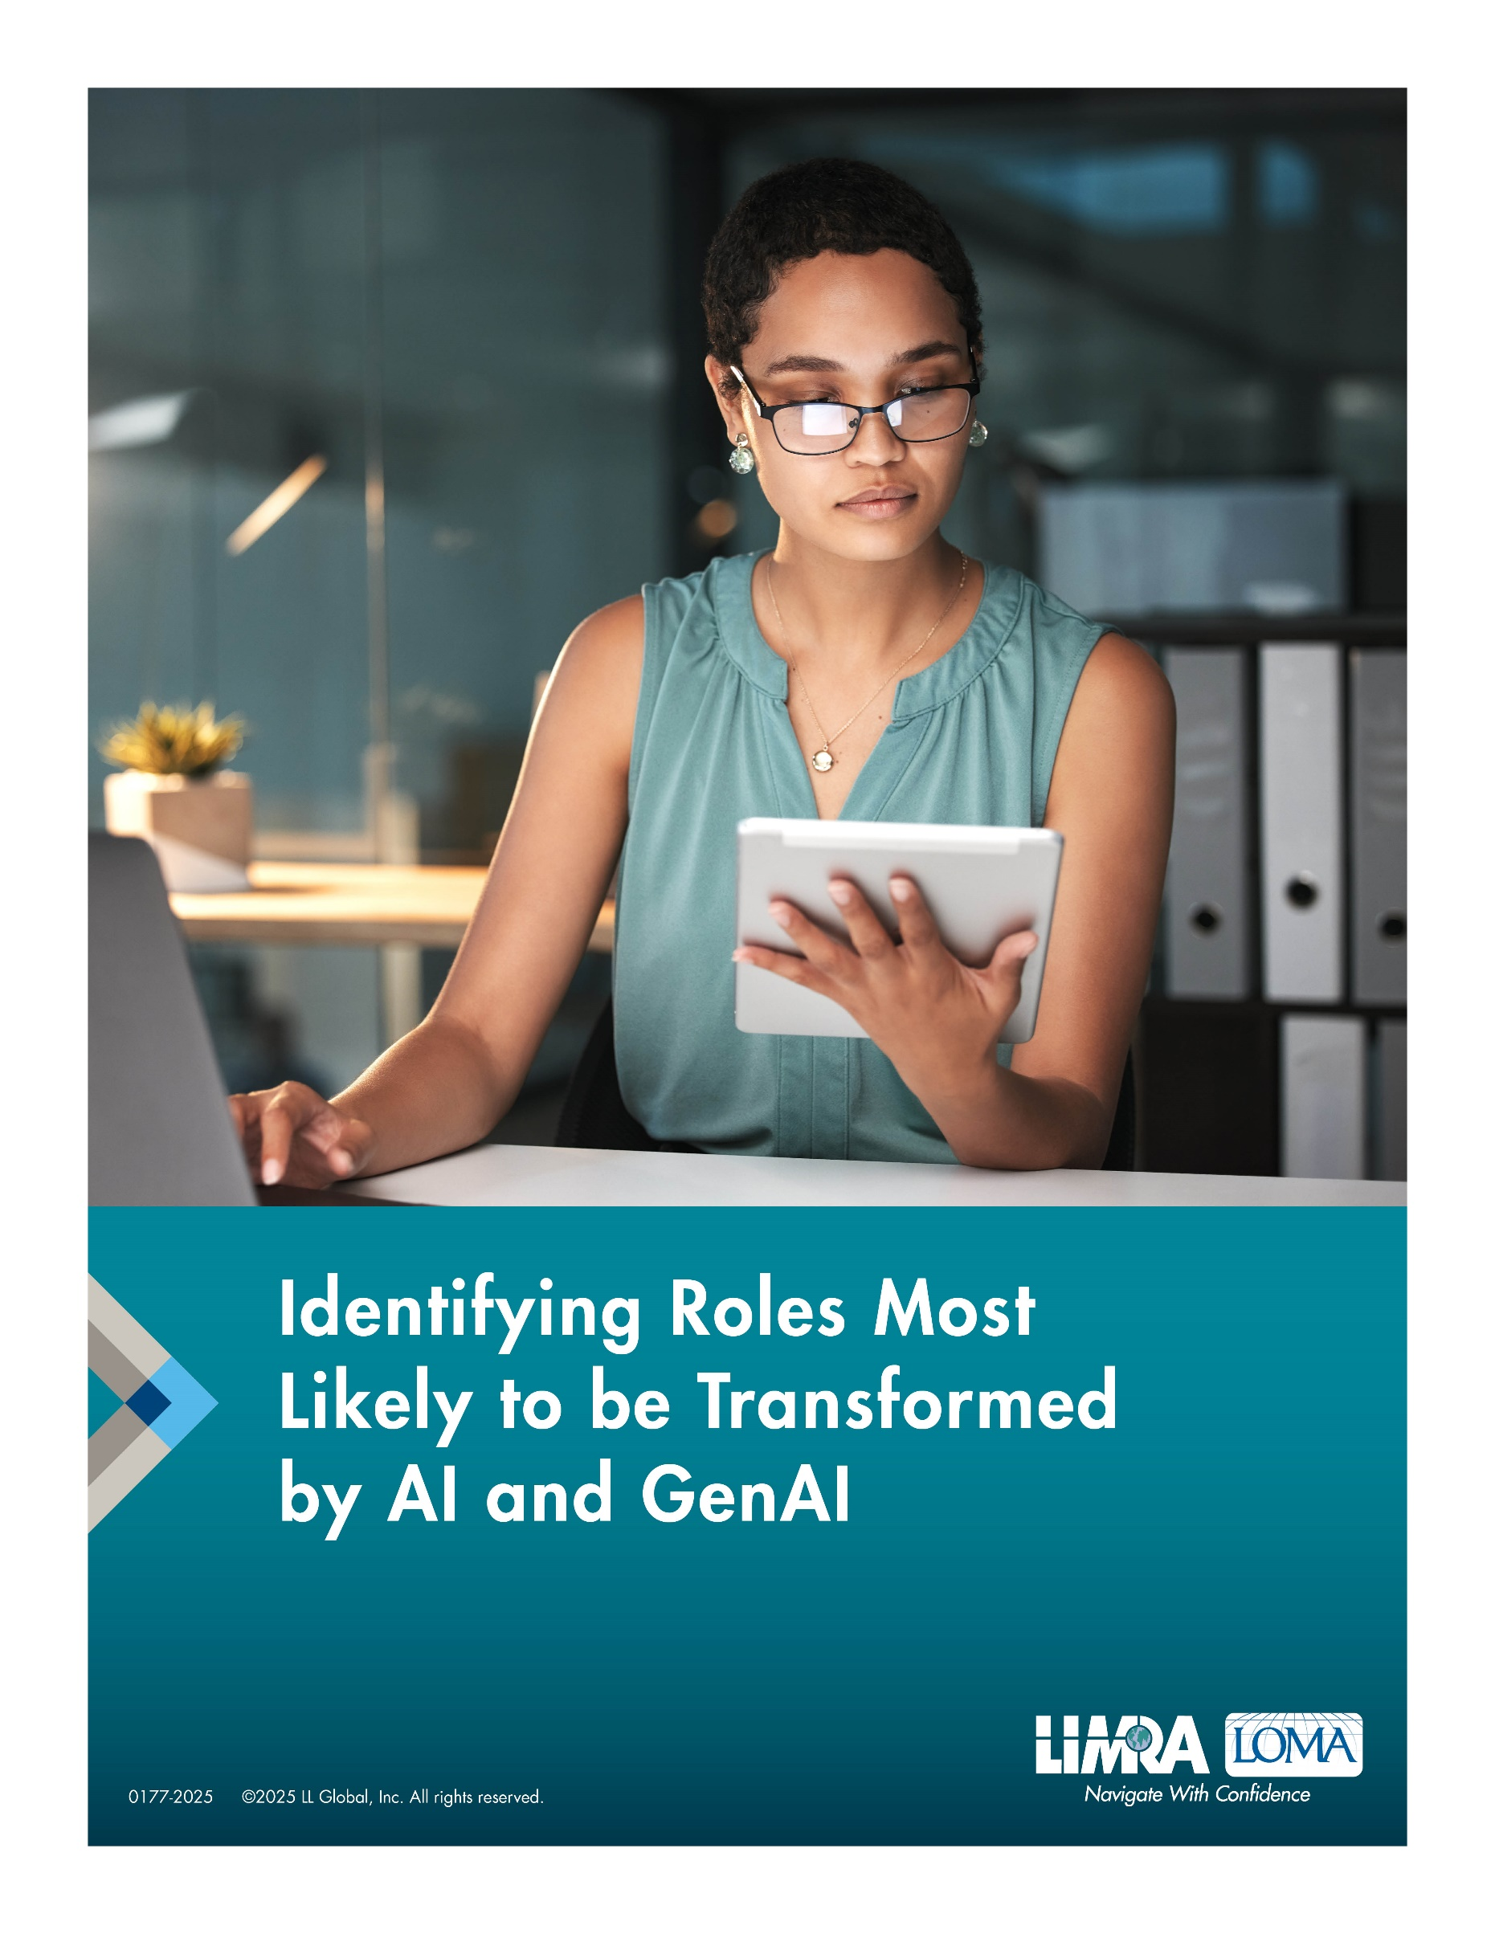

**For Additional Information:**

**Kartik Sakthivel, Ph.D., MS-IT/MS-CS, MBA, PGC-IQ**  
Vice President & Chief Information Officer   
LIMRA and LOMA  
[ksakthivel@limra.com](mailto:ksakthivel@limra.com)

Created in Collaboration with the LIMRA and LOMA AI Governance Group

# 1.0 Introduction

Artificial intelligence (AI), and generative AI (GenAI) as a type of AI, are poised to effectuate significant change and transformation across the insurance industry. Regardless of how mature or established an industry might be, AI is rapidly transforming sectors across the world, and the insurance sector is no exception. The LIMRA and LOMA AI Governance Group (AIGG), established in January of 2024, is a cross-company industry-level consortia of over 100+ business and technology executives, representing over 55+ member companies (as of Q4 2024). According to a survey emerging from this group that was published in Q3 of 2024, 89 percent of executives believe that AI will have a moderate to significant impact on our industry over the next three years, and 70 percent of them believe that AI will have a moderate to significant impact on their firms.

The use of AI within the insurance industry is not new. LIMRA research on automated and accelerated underwriting — underwriting that leverages AI (machine learning) — published in 2017, found that less than 50 percent of carriers surveyed were employing AI within underwriting. When this benchmark was refreshed in 2021, that number had jumped to   
93 percent. In addition to the use of AI within underwriting, AI has been deployed across functions including, but not limited to, actuarial, marketing, claims management, customer engagement, customer service, fraud detection, and risk management. The *AIGG Phase One — Current State Assessment* research reports published through Q3 and Q4 2024 found that although AI has been leveraged across the insurance value chain for several years, it had been done so in organizational silos. These stovepipe type implementations have disallowed firms to achieve economies of scale and scope, prevented knowledge sharing, and stymied the ability of a firm to develop an enterprise-level strategic approach towards AI that is tied to direct business outcomes. One of the side-effects of having these function-based AI implementations has been that leaders have not been able to have a clear sense of how AI will transform the jobs of tomorrow. Amongst other challenges, leaders have been unable to discern:

a. How to intentionally hire with these future job skills in mind,

b. What kind of productivity can they anticipate,

c. What kinds of functions across the value chain can anticipate FTE savings,

d. How these savings can be redeployed, and,

e. How to skill and reskill existing talent to be able to capitalize on AI’s potential.

# 2.0 The Importance of Identifying Jobs Most Likely to Transform

AI is revolutionizing core functions within the insurance value chain. However, as these technologies become more sophisticated, they will inevitably reshape the workforce, fundamentally changing how tasks are performed, and which skills are most valuable. If there are rote, repeatable, operational tasks that employees across the insurance value chain perform at work, they will likely be automated by virtue of AI. The adoption of AI across a firm brings with it the inevitability of changes in the current nature of individual jobs, and shifts in the workforce of the near future. As organizations across industries realize benefits from their AI programs, several job functions across the insurance value chain, from routine administrative roles to more complex decision-making positions, are likely to change, with these changes potentially impactful in nature. And whereas these changes will first impact rote, repeatable, data-driven, and rule-based tasks, it is likely that the impacts from these changes will be felt across every facet of the insurance value chain, including in underwriting, claims, customer service, fraud detection, etc.

To prepare for these changes, firms need to conduct a comprehensive analysis of the jobs across the organization that are most likely to be affected by AI. This involves mapping current roles to the tasks they involve, identifying which of those tasks can be automated, and determining the level of human oversight required. It should be noted that GenAI, as a type of an AI implementation, has unique capabilities that extend beyond traditional AI. These capabilities include creation of original content, summarization of documents, generation of insights from unstructured data, etc. The impact of GenAI is more nuanced than is with traditional AI and will impact jobs that require content and knowledge creation, decision support, and content management. Unless firms can identify which roles are the likeliest to see the most impact, and the soonest impact, they are susceptible to falling behind and decreased competitiveness as a result of workforce disruptions and talent skill gaps. Identifying which roles across the value chain are likely to be most impacted by AI will allow firms to develop a proactive hiring and reskilling strategy. A reskilling strategy will ensure that employees are not left behind as AI continues to take on more tasks. This proactive approach is crucial for two key reasons: to prevent potential disruptions in the workforce and to position the organization to capitalize on new opportunities presented   
by AI.

By identifying roles that are most likely to experience change early, insurance companies can begin planning how to transition employees into new, future-ready roles. Firms can equip their workforce with the skills necessary to succeed in an environment where AI augments their roles and allows for operational efficiencies across the organization. Reskilling will also allow organizations to focus on developing inherently human skills that are unlikely to be automated by AI. These include developing knowledge of the business by investing in programs such as LOMA professional development, building soft skills, critical thinking, creativity, leadership, complex problem solving, etc. It is therefore important that firms undertake a strategic approach to begin identifying which jobs will be most susceptible to this transformation now, allowing companies to begin developing targeted reskilling and upskilling programs to ensure employees are ready to adapt to new AI-augmented roles.

# 3.0 Getting Started

AI is evolving at an exponential rate. The fast pace of AI’s advancement and the significant lead time required to effectively reskill and upskill employees across the value chain necessitates that firms plan and commence the process sooner rather than later.   
Waiting until AI is fully embedded across the value chain could lead to workforce disruptions and employee skill gaps, as well as stymie the ability to attract and retain   
talent (especially within technology), and ultimately, might result in competitive disadvantages. Employees in roles that are being transformed by AI might find themselves unprepared or underprepared for the future of work if these reskilling efforts are not initiated early. Although carriers have established a symbiotic relationship between carriers and InsurTech firms, carriers continue to be vulnerable to competitive pressure from tech-driven startups. These technology-native firms will likely leverage AI to deliver faster, more personalized services.

Companies that delay adapting their workforce to AI will struggle to keep pace with these more agile competitors. Even if a carrier ends up investing in or partnering with an InsurTech company, employees at the carrier need to be conversant, if not fluent, in the same skills that these InsurTech providers have. Unless there is a “common language” in terms of a core set of skills, it will be challenging for a carrier to fully capitalize on the value of investing in, or partnering with, an InsurTech firm. A pragmatic reskilling strategy helps mitigate these risks but also positions the organization to capitalize on the opportunities presented by AI. Firms can help their employees transition to roles that add higher strategic value, such as interpreting AI-driven insights, improving client relationships, and managing complex problems that require human oversight.

Identifying jobs that are most likely to transform is the first step of a comprehensive enterprise AI skilling/reskilling strategy. Using the accompanying guidelines and template, companies should conduct a comprehensive analysis of the jobs across the organization that are most likely to be affected by AI. This involves mapping current roles to the tasks they involve, identifying which of those tasks can be automated, and determining the level of human oversight required. With this understanding, firms can begin developing targeted reskilling and upskilling programs to ensure that their employees are ready to adapt to new AI-augmented roles. This approach is crucial for maintaining operational continuity and creating a more agile, future-ready workforce.

